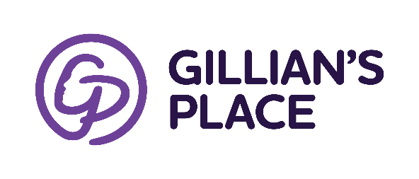
Career Opportunity

Position: Relief Counsellor (Shelter)

Number of Hours: Hours and time of day will vary.
Candidate must be available for day, afternoon, and overnight shifts on weekdays and weekends. Relief Counsellors are scheduled on a casual basis and work on average anywhere from 1 to 5 shifts per week based on their availability and the needs of the shelter.
In this position, you will be responsible for working within the Counselling department and responding to day-to day needs of the shelter, its residents, and the crisis/support line. Reporting to the Manager of Counselling Services, a Relief Counsellor will have a mix of duties including:
- Providing crisis intervention, safety planning and community referrals for outreach and residential clients
- Responding to crisis calls and determining eligibility for entry into the shelter
- Assisting clients with options, resources, and support
- Facilitating communal living and services within shelter
- Ensuring accurate and professional data collection, documentation, and reporting
- Maintaining an active knowledge of community service providers and collaborate as required
Skills and Qualifications required
- University degree in Social Work/related field or equivalent experience
- Extensive knowledge of gendered based violence issues and counselling skills
- Strong understanding of a harm reduction framework
- Ability to support clients with varying levels of addiction and mental wellness
- A high degree of honesty, integrity, discretion, and confidentiality is required
- Ability to handle a crisis, work in a team, carry out independent decision-making, and handle several tasks simultaneously
- Strong written and verbal communication skills and computer proficiency
All interested applicants should apply by emailing humanresources@gilliansplace.com
Please be advised we only contact applicants who are selected for an interview. Gillian’s Place is an equal opportunity employer that encourages people of colour, First Nations/Aboriginal individuals, newcomers and immigrants, members of the 2SLGBTQ+ community, people of all abilities, and members of other underrepresented communities to apply.

